**Main parameters in using AFFSEN function**

Use the AFFSEN function to find significant predictors and estimate a smooth version of them in a high dimensional case. We have option to control sparsity and smoothness separately with using two penalty parameters $λ_{H}$ and $λ_{K}$. We aim to estimate a smooth version of $β$ s minimize the following target function.

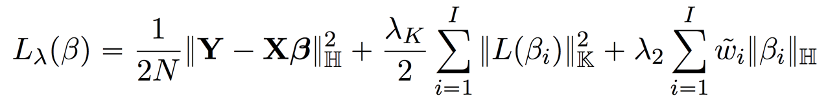

The following AFFSEN function helps us to estimate the $β$ and find the significant predictors.

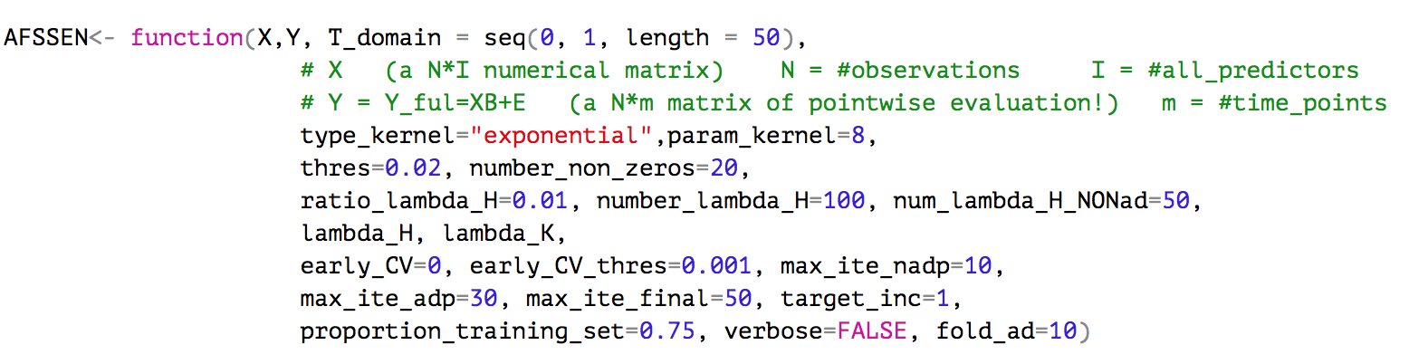

In the following table you can find the functionality of each parameters:

|  |  |  |
| --- | --- | --- |
|  | functionality | Details |
| X | Numerical design matrix | It should be a N*I matrix  N= #observations ; I = #predictors |
| Y | Matrix of pointwise evaluation for observations on T_domain | It should be a N*m matrix. |
| T_domain | Time domain for evaluation of Y and generating kernel | Default : T_domain = seq(0,1,m=50) |
| type_kernel | Type of kernel | ‘exponential’, ‘gaussian’, ‘sobolev’ |
| param_kernel | Kernel parameter | In all types, the time domain is seq(0,1,50) |
| thres | Stopping criteria:  beta increment threshold |  |
| number_non_zeros | Stopping Criteria:  Kill switch; number of nonzero predictors |  |
| ratio_lambda_H | $$\frac{λ_{Hmax}}{λ_{Hmin}}$$ |  |
| number_lambda_H | Generate number of log-equally spaced $λ_{H}$ in $[λ_{Hmin},λ_{Hmax}]$ |  |
| num_lambda_H_NONad | Number of $λ_{H}$ in non-adaptive step |  |
| lambda_H | You have option to insert a vector of $λ_{H}$ | If you want to make the log-equally spaced by above parameters, just set lambda_H=numeric() |
| lambda_K | Vector of $λ_{K}$ |  |
| early_CV | 0 or 1 : applying the “early_CV_thres” stopping criteria or not. |  |
| early_CV_thres | Stopping Criteria:  Breaking point in CV plot. |  |
| max_ite_nadp | Stopping Criteria:  Maximum iteration of coordinate descent alg. in non-adaptive step |  |
| max_ite_adp | Stopping Criteria:  Maximum iteration of coordinate descent alg. in adaptive step |  |
| max_ite_final | Stopping Criteria:  Maximum iteration of coordinate descent alg. for the optimum $λ_{H}$ and $λ_{K}$ |  |
| target_inc | Stopping Criteria:  0 or 1 : if target function is increased, stop |  |
| proportion_training_set | Proportion of training set for estimation in non-adaptive step. |  |
| fold_ad | Number of fold for using CV in adaptive steps to find optimum $λ_{H}$ and $λ_{K}$ and then estimation. |  |